Assignment 2- Case Study

Stage 3 Lab Activities

SmartCare Domain Modelling
AI OFF -> AI ON -> COMPARE -> VERIFY | 1 hour

A - Requirements Review
Highlight nouns, verbs and business rules in SmartCare v0.2.
Nouns:
Patient, Practitioner, Appointment, Date, Time, Status, Appointment History

Verbs:
Create, store, associate, prevent, search, record, cancel, retain

Business Rules:
- Each appointment is associated with a patient and practitioner.
- Duplicate bookings for the same practitioner at the same time must be prevented.
- Cancelled appointments are retained in appointment history.

B - Candidate Classes
Record candidate concepts, supporting requirements, state and behaviour.
Requirement | Concept | State/behaviour | Decision
FR-01 Create an appointment | Appointment | Behaviour – create appointment | Keep as class
FR-02 Store patient information | Patient | State – patient information | Keep as class
FR-03 Store practitioner information | Practitioner | State – practitioner information | Keep as class
FR-04 Associate patient and practitioner with appointment | Appointment | State – patient and practitioner | Keep as class
FR-05 Store appointment date and time | Appointment | State – date/time | Keep as attribute
FR-06 Prevent duplicate bookings | Appointment | Behaviour – check booking conflict | Keep as behaviour
FR-07 Search for patient information | Patient | Behaviour – search patient | Keep as behaviour
FR-08 Record appointment status | Appointment | State – status | Keep as attribute
FR-09 Cancel an appointment | Appointment | Behaviour – cancel appointment | Keep as behaviour
FR-10 Retain appointment history | Appointment | State – appointment/history | Keep with Appointment

C - CRC Cards
Create CRC cards for Patient, Practitioner and Appointment.

Patient
Responsibilities | Collaborators
Store patient information | Appointment
Provide patient details | Appointment

Practitioner
Responsibilities | Collaborators
Store practitioner information | Appointment
Provide practitioner details | Appointment

Appointment
Responsibilities | Collaborators
Store appointment date/time | Patient
Record appointment status | Practitioner

D - UML Model
Draw classes, attributes, operations, associations and multiplicities.
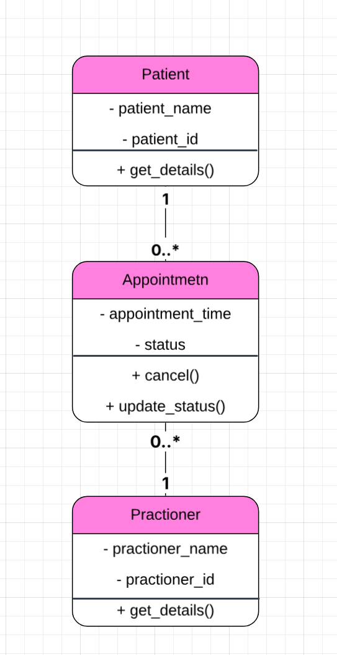

E - AI Design Review
Ask AI to suggest classes and relationships using only confirmed requirements; require supporting requirement IDs.

F - Compare and Decide
Record at least one accepted, modified and rejected AI suggestion.
AI suggestion | Evidence | Decision | Reason | Model change
Use Patient, Practitioner and Appointment as the main classes | FR-01 to FR-10 | Accepted | These classes are directly supported by the confirmed requirements and match the original model. | No change needed
Store appointment history as an attribute of Appointment | FR-10 | Modified | Appointment history is better represented by retaining previous Appointment objects rather than storing history as a single attribute. | Removed history as an Appointment attribute
Add searchPatient() as a behaviour of Patient | FR-07 | Rejected | Searching across patients does not fit the responsibility of one individual Patient object. | searchPatient() was not added to Patient
Use one-to-many relationships between Patient–Appointment and Practitioner–Appointment | FR-04, FR-06, FR-10 | Accepted | A patient or practitioner can be associated with multiple appointments, while each appointment has one patient and one practitioner. | Relationships kept in final UML

G - Python Skeletons
Create simple Patient, Practitioner and Appointment class skeletons.
Python.py

H - Consistency Check
Check model-code consistency; do not implement full behaviour yet.
The Python class skeletons were compared with the UML model. Patient, Practitioner and Appointment contain the same main attributes and operations shown in the model. No extra classes or full behaviour were added.

Reflection
What modelling decision was hardest? Where did AI over-design? What evidence supported your final choices?
The hardest modelling decision was deciding which behaviours should belong to each class. AI suggested some ideas that could make the model more complicated, such as treating appointment history as an attribute and putting patient searching inside the Patient class. I modified or rejected these where they did not fit the responsibilities of the classes. My final choices were based on the confirmed SmartCare requirements and the requirement IDs used throughout the model.

